

**Title: Project task# 4(Low-Fi Prototype)**

**Subject:** Human Computer Interaction

**Submitted To:** Dr. Zubair Malik

**Submitted By:**

Zeeshan Muzammal   (BSCS13010)

Arslan Ahmad   (BSCS13023)

Ayesha Asghar   (BSCS13033)

Abdul Monam   (BSCS13039)

Submission Date:

May 7, 2017

Table of Contents

Low-Fi Prototype 3

Mission Statement/Value Proposition 3

Problem Overview 3

Solution Overview 3

Three Main Tasks: 3

o Simple 3

o Medium 3

o Complex 3

Sketches: 4

**Simple Task(Sketch):** 4

**Moderate Task (Sketch):** 5

**Complex Task (Sketch):** 5

Prototype: 7

Description: 8

Selected Interface Design: 9

Testing Methods 9

**Level of comfort ability:** 10

**Errors or unexpected clicks:** 10

**Level of excitement:** 10

Result from Simple Task: 10

The Good: 10

The Bad: 10

Result from Moderate Task: 10

The Good: 10

The Bad: 10

Result from Complex Task: 10

The Good: 10

The Bad: 10

Things that worked 11

Things that did not work 11

# Low-Fi Prototype

## Mission Statement/Value Proposition

* All unbiased news along with Personalized News

## Problem Overview

* Most of the people get news that are biased toward specific people or society. All available sources of news provide separate news about same topic that confuses people. Some people want to see news only related to their interests.

## Solution Overview

* Providing a mobile app that will provide news using tweets of people anchor and news channels. User can also make his profile there to get news related to his/her interest. This would be unbiased because it will give news and comparison with other news channels at the same time.

## Three Main Tasks:

### Simple

A user wants to see all news of the days.

### Medium

A user want to see hot news of specific time.

### Complex

A user want to see news related to his interests.

## Sketches:

We sketched ideas for three different platforms (watch, mobile, and tablet), and explored three

Different mobile design ideas.

### **Simple Task(Sketch):**

A user wants to see all news of the days.

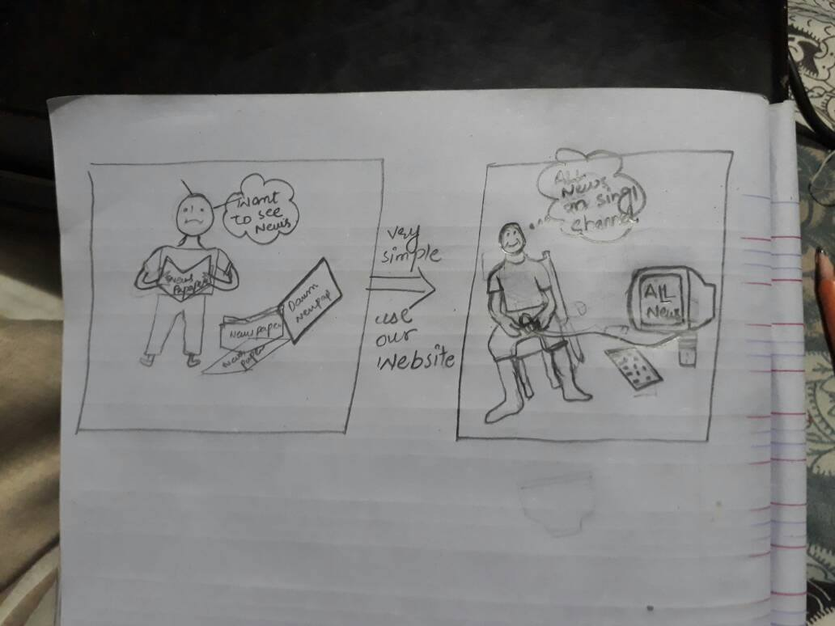

### **Moderate Task (Sketch):**

A user want to see hot news of specific time.

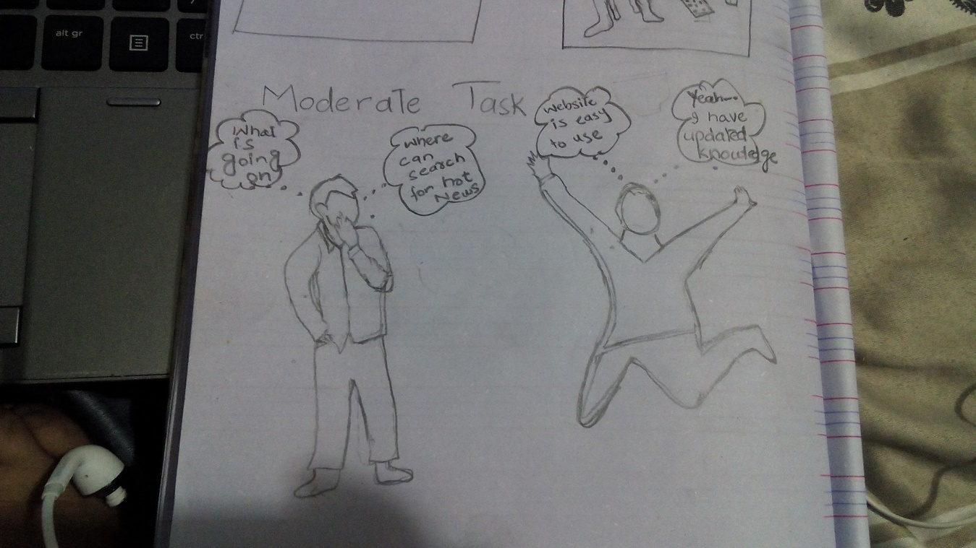

### **Complex Task (Sketch):**

A user want to see news related to his interest

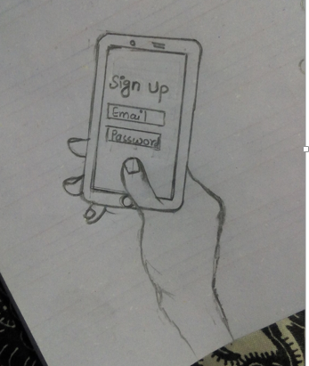

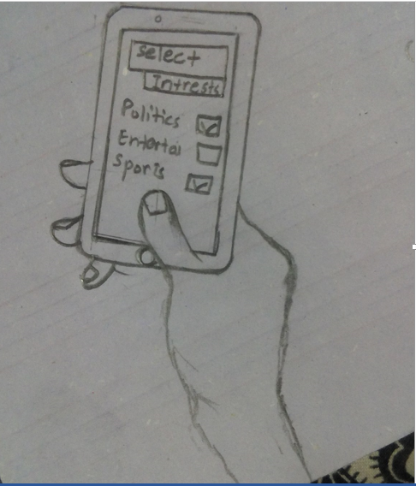

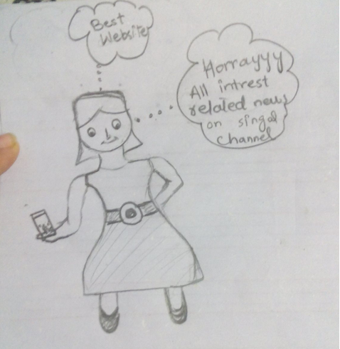

## Prototype:

For our prototype we folded a piece of paper to emulate a standard mobile device. We then created

Multiple scenes out of paper that would emulate every screen of our app. Additionally, we used colored sticky notes to act as notifications and buttons.

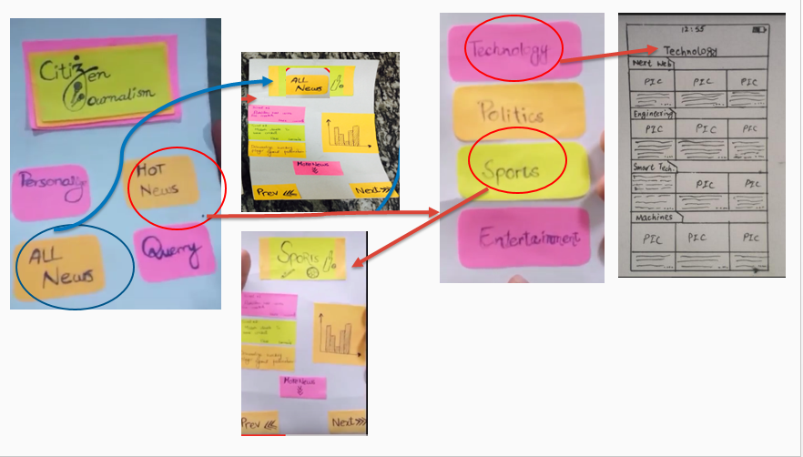

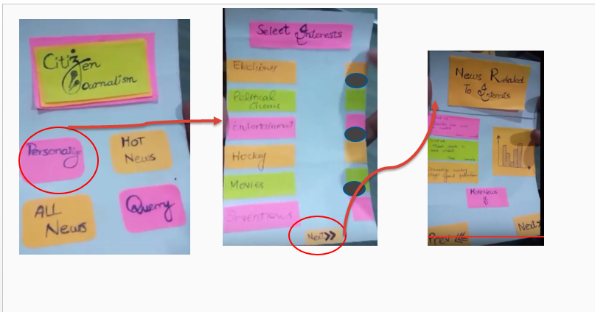

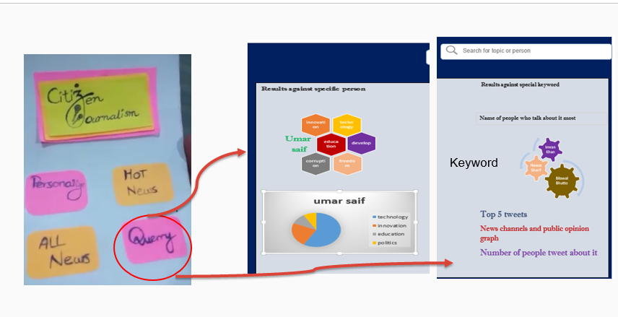

### Description:

Our design start with front page describes and main categories of system those are Personlize news, hot news, All news and Query.

If user will click on personalize news he/she will see the news related to his interest that will also save his time.

If he/she will click on the Hot news news like a head lines will be show to him.

And another option is for query where if a person click on the query two option will be provided to him one for person search and other for keyword he will get news related to that keyword or person according to his selection.

Query related to person also tell us that about which news he/she talks about mostly. And what are his most recent activites.

Query of keyword will also describes that which person talks about these news in most of the time.

## Selected Interface Design:

|  |  |
| --- | --- |
| **Pros** | **Cons** |
| * Large percentage of population owns a   Smartphone | * Having a mobile app is not original |
| * People almost always have their phone on them while watching news or reading newspapers | * Screen may be too small for some people to navigate |
| * Liked the social aspect of the news in our prototype | * A lot of textual data may be boring |
| * Happy to see news only related to their interest |  |
| * Factor of unbiased news was apprenticed |  |

## Testing Methods

We prefer literate people as illiterate find it difficult to interact with technology and for this purpose we chose universities as well as shopping Malls as there we can find literate people also who have knowledge and know importance of their point of view and have enough knowledge about issues and problems of society. Before testing we first introduced ourselves and explained product. After this we ask general questions and make them comfortable so that they enjoy the whole process. Next we showed them our cardboard prototypes and explained the flow by swiping them like mobile screens.

### **Level of comfort ability:**

One of our member write down what they were saying and also write about their expression how much they are comfortable with design. Do they find it easy and going with actual flow?

### **Errors or unexpected clicks:**

We also write down how many errors they made while using prototype, how many times they stuck while using app. All these minor detail wrote down by our team member.

### **Level of excitement:**

Were they excited for this project by facial expressions? These details were helpful in analyzing our design flaws as well as user's convenience.

## Result from Simple Task:

### The Good:

Enthusiasm

Novelty

### The Bad:

Swiping (May be due to card board)

## Result from Moderate Task:

### The Good:

Save time

Nice to see irrelevant things way

### The Bad:

Text a lot.

## Result from Complex Task:

### The Good:

Details Screen

Filters

### The Bad:

Lack of Picture reduce Interest

## Things that worked

* Like news presented in graphs
* Part they like about prototype was personalized news
* Make no errors almost while using mockups
* Create log in easily using mockups

## Things that did not work

* They were not much comfortable with heavy texts
* Do not want tweets of different personalities
* Want concise form of news extracted from those tweet